Smart Contracts in Blockchain

A Smart Contract (or cryptocontract) is a computer program that directly and automatically controls the transfer of digital assets between the parties under certain conditions. A smart contract works in the same way as a traditional contract while also automatically enforcing the contract. Smart contracts are programs that execute exactly as they are set up (coded, programmed) by their creators. Just like a traditional contract is enforceable by law, smart contracts are enforceable by code.
- The bitcoin network was the first to use some sort of smart contract by using them to transfer value from one person to another.
- The smart contract involved employs basic conditions like checking if the amount of value to transfer is actually available in the sender account.
- Later, the Ethereum platform emerged which was considered more powerful, precisely because the developers/programmers could make custom contracts in a Turing-complete language.
- It is to be noted that the contracts written in the case of the bitcoin network were written in a Turing-incomplete language, restricting the potential of smart contracts implementation in the bitcoin network.
- There are some common smart contract platforms like Ethereum, Solana, Polkadot, Hyperledger fabric, etc.

History:

In 1994, Nick Szabo, a legal scholar, and a cryptographer recognized the application of a decentralized ledger for smart contracts. He theorized that these contracts could be written in code which can be stored and replicated on the system and supervised by the network of computers that constitute the blockchain. These smart contracts could also help in transferring digital assets between the parties under certain conditions.

Features of Smart Contracts

The following are some essential characteristics of a smart contract:
- Distributed: Everyone on the network is guaranteed to have a copy of all the conditions of the smart contract and they cannot be changed by one of the parties. A smart contract is replicated and distributed by all the nodes connected to the network.
- Deterministic: Smart contracts can only perform functions for which they are designed only when the required conditions are met. The final outcome will not vary, no matter who executes the smart contract.
- Immutable: Once deployed smart contract cannot be changed, it can only be removed as long as the functionality is implemented previously.
- Autonomy: There is no third party involved. The contract is made by you and shared between the parties. No intermediaries are involved which minimizes bullying and grants full authority to the dealing parties. Also, the smart contract is maintained and executed by all the nodes on the network, thus removing all the controlling power from any one party’s hand.
- Customizable: Smart contracts have the ability for modification or we can say customization before being launched to do what the user wants it to do.
- Transparent: Smart contracts are always stored on a public distributed ledger called blockchain due to which the code is visible to everyone, whether or not they are participants in the smart contract.
- Trustless: These are not required by third parties to verify the integrity of the process or to check whether the required conditions are met.
- Self-verifying: These are self-verifying due to automated possibilities.
- Self-enforcing: These are self-enforcing when the conditions and rules are met at all stages.

Capabilities of Smart Contracts
- Accuracy: Smart contracts are accurate to the limit a programmer has accurately coded them for execution.
- Automation: Smart contracts can automate the tasks/ processes that are done manually.
- Speed: Smart contracts use software code to automate tasks, thereby reducing the time it takes to maneuver through all the human interaction-related processes. Because everything is coded, the time taken to do all the work is the time taken for the code in the smart contract to execute.
- Backup: Every node in the blockchain maintains the shared ledger, providing probably the best backup facility.
- Security: Cryptography can make sure that the assets are safe and sound. Even if someone breaks the encryption, the hacker will have to modify all the blocks that come after the block which has been modified. Please note that this is a highly difficult and computation-intensive task and is practically impossible for a small or medium-sized organization to do.
- Savings: Smart contracts save money as they eliminate the presence of intermediaries in the process. Also, the money spent on the paperwork is minimal to zero.
- Manages information: Smart contract manages users’ agreement, and stores information about an application like domain registration, membership records, etc.
- Multi-signature accounts: Smart contracts support multi-signature accounts to distribute funds as soon as all the parties involved confirm the agreement.

How Do Smart Contracts Work?
A smart contract is just a digital contract with the security coding of the blockchain.
- It has details and permissions written in code that require an exact sequence of events to take place to trigger the agreement of the terms mentioned in the smart contract.
- It can also include the time constraints that can introduce deadlines in the contract.
- Every smart contract has its address in the blockchain. The contract can be interacted with by using its address presuming the contract has been broadcasted on the network.
The idea behind smart contracts is pretty simple. They are executed on a basis of simple logic, IF-THEN for example:
- IF you send object A, THEN the sum (of money, in cryptocurrency) will be transferred to you.
- IF you transfer a certain amount of digital assets (cryptocurrency, for example, ether, bitcoin), THEN the A object will be transferred to you.
- IF I finish the work, THEN the digital assets mentioned in the contract will be transferred to me.
Note: The WHEN constraint can be added to include the time factor in the smart contracts. It can be seen that these smart contracts help set conditions that have to be fulfilled for the terms of the contract agreement to be executed. There is no limit on how much IF or THEN you can include in your intelligent contract.

Smart Contract Working
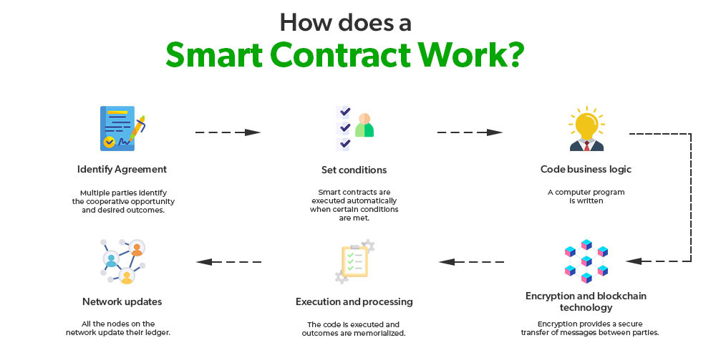

- Identify Agreement: Multiple parties identify the cooperative opportunity and desired outcomes and agreements could include business processes, asset swaps, etc.
- Set conditions: Smart contracts could be initiated by parties themselves or when certain conditions are met like financial market indices, events like GPS locations, etc.
- Code business logic: A computer program is written that will be executed automatically when the conditional parameters are met.
- Encryption and blockchain technology: Encryption provides secure authentication and transfer of messages between parties relating to smart contracts.
- Execution and processing: In blockchain iteration, whenever consensus is reached between the parties regarding authentication and verification then the code is executed and the outcomes are memorialized for compliance and verification.
- Network updates: After smart contracts are executed, all the nodes on the network update their ledger to reflect the new state. Once the record is posted and verified on the blockchain network, it cannot be modified, it is in append mode only.

Applications of Smart Contracts
- Real Estate: Reduce money paid to the middleman and distribute between the parties actually involved. For example, a smart contract to transfer ownership of an apartment once a certain amount of resources have been transferred to the seller’s account(or wallet).
- Vehicle ownership: A smart contract can be deployed in a blockchain that keeps track of vehicle maintenance and ownership. The smart contract can, for example, enforce vehicle maintenance service every six months; failure of which will lead to suspension of driving license.
- Music Industry: The music industry could record the ownership of music in a blockchain. A smart contract can be embedded in the blockchain and royalties can be credited to the owner’s account when the song is used for commercial purposes. It can also work in resolving ownership disputes.
- Government elections: Once the votes are logged in the blockchain, it would be very hard to decrypt the voter address and modify the vote leading to more confidence against the ill practices.
- Management: The blockchain application in management can streamline and automate many decisions that are taken late or deferred. Every decision is transparent and available to any party who has the authority(an application on the private blockchain). For example, a smart contract can be deployed to trigger the supply of raw materials when 10 tonnes of plastic bags are produced.
- Healthcare: Automating healthcare payment processes using smart contracts can prevent fraud. Every treatment is registered on the ledger and in the end, the smart contract can calculate the sum of all the transactions. The patient can’t be discharged from the hospital until the bill has been paid and can be coded in the smart contract.
Example Use cases:
- Smart contracts provide utility to other contracts. For example, consider a smart contract that transfers funds to party A after 10 days. After 10 days, the above-mentioned smart contract will execute another smart contract which checks if the required funds are available at the source account(let’s say party B).
- They facilitate the implementation of ‘multi-signature’ accounts, in which the assets are transferred only when a certain percentage of people agree to do so
- Smart contracts can map legal obligations into an automated process.
- If smart contracts are implemented correctly, can provide a greater degree of contractual security.

Advantages of Smart Contracts
- Recordkeeping: All contract transactions are stored in chronological order in the blockchain and can be accessed along with the complete audit trail. However, the parties involved can be secured cryptographically for full privacy.
- Autonomy: There are direct dealings between parties. Smart contracts remove the need for intermediaries and allow for transparent, direct relationships with customers.
- Reduce fraud: Fraudulent activity detection and reduction. Smart contracts are stored in the blockchain. Forcefully modifying the blockchain is very difficult as it’s computation-intensive. Also, a violation of the smart contract can be detected by the nodes in the network and such a violation attempt is marked invalid and not stored in the blockchain.
- Fault-tolerance: Since no single person or entity is in control of the digital assets, one-party domination and situation of one part backing out do not happen as the platform is decentralized and so even if one node detaches itself from the network, the contract remains intact.
- Enhanced trust: Business agreements are automatically executed and enforced. Plus, these agreements are immutable and therefore unbreakable and undeniable.
- Cost-efficiency: The application of smart contracts eliminates the need for intermediaries(brokers, lawyers, notaries, witnesses, etc.) leading to reduced costs. Also eliminates paperwork leading to paper saving and money-saving.

Challenges of Smart Contracts
- No regulations: A lack of international regulations focusing on blockchain technology(and related technology like smart contracts, mining, and use cases like cryptocurrency) makes these technologies difficult to oversee.
- Difficult to implement: Smart contracts are also complicated to implement because it’s still a relatively new concept and research is still going on to understand the smart contract and its implications fully.
- Immutable: They are practically immutable. Whenever there is a change that has to be incorporated into the contract, a new contract has to be made and implemented in the blockchain.
- Alignment: Smart contracts can speed the execution of the process that span multiple parties irrespective of the fact whether the smart contracts are in alignment with all the parties’ intention and understanding.

